SG1 - Requirements Specification
Online Course Evaluation System

System Description
The Online Course Evaluation System (OCES) is a website that allows students to evaluate courses taken during the semester. Rather than a paper-based evaluation currently used, students will visit the website in a pre-defined period towards the end of the semester, and evaluate the course contents and lecturer. This system will allow staff, lecturers and management to rapidly collect information from the evaluations. It will show reports for different users, e.g. allow lecturers to compare their evaluations against school and institute averages, allow management to view trends in evaluations across schools, lecturers and semesters.

Perspective
The relationship between OCES and other systems and users is shown in Figure 1.
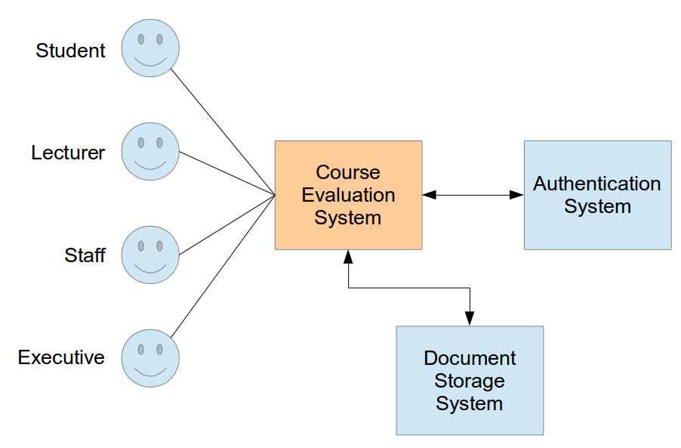Figure 1: System Perspective
OCES will not implement its own authentication system. Instead the existing SIIT Authentication System will be used, allowing the users to be authenticated against the current database. Also, reports from OCES (in PDF format) will be automatically deposited in the existing SIIT Document Management System.
Users can be classified as: students, staff, lecturers and executive (management).

Functions
The functions of OCES are shown in Figure 2.
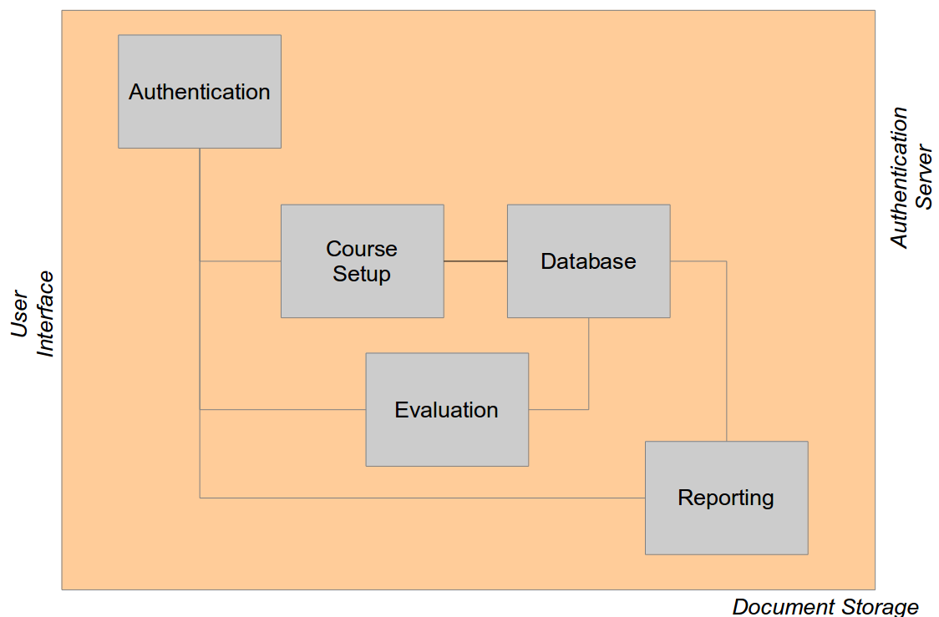Figure 2: System Functions
The functions are summarised as:
- Authentication: connects with the external SIIT Authentication system to check user logins and determine the access control
- Course Setup: allows staff to add new courses, including who is the lecturer/TA for each course
- Evaluation: allows students to perform the evaluation
- Reporting: allows different types of users to produce summary reports from a set of evaluations. PDF reports may be stored in the external SIIT Document Management system.

Requirements
The requirements of the system are listed in the following subsections.

General
- OCES must ...
- OCES should ...
- OCES may ...

Authentication
- The Authentication module must ...
- The Authentication module must ...
- The Authentication module must ...

Reporting
- The Reporting module must ...
- The Reporting module must ...
- The Reporting module must ...
...

